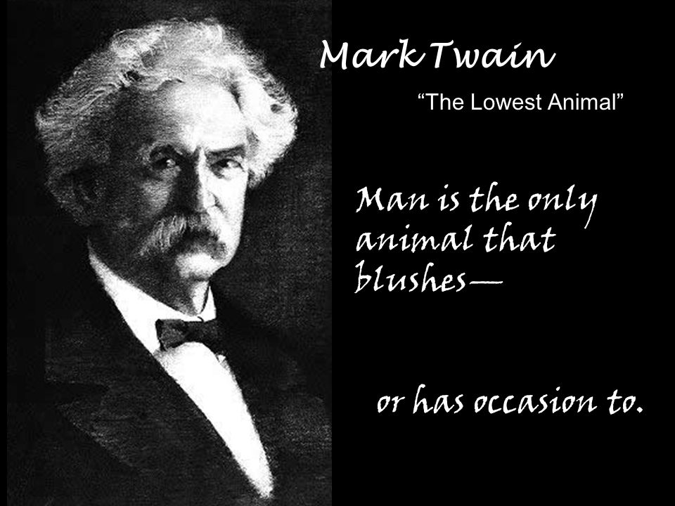

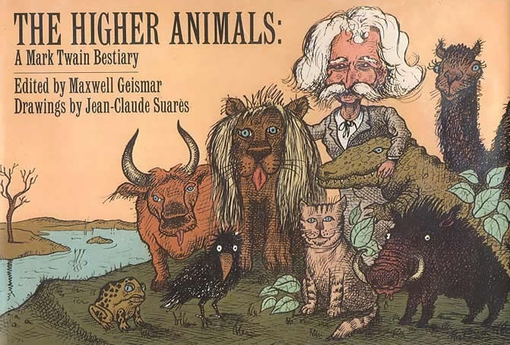

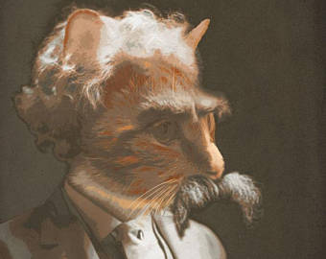

The Lowest Animal

1896
Mark Twain
I have been scientifically studying the traits and dispositions of the "lower animals" (so-called), and contrasting them with the traits and dispositions of man. I find the result humiliating to me. For it obliges me to renounce my allegiance to the Darwinian theory of the Ascent of Man from the Lower Animals; since it now seems plain to me that the theory ought to be vacated in favor of a new and truer one, this new and truer one to be named the Descent of Man from the Higher Animals.
In proceeding toward this unpleasant conclusion I have not guessed or speculated or conjectured, but have used what is commonly called the scientific method.

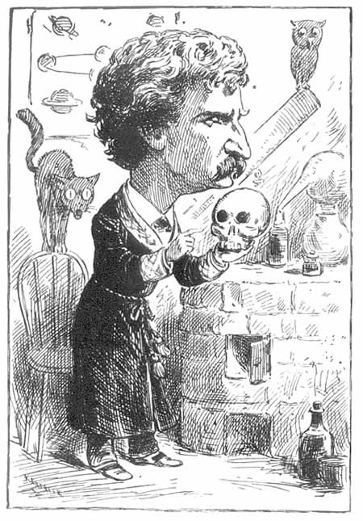
That is to say, I have subjected every postulate that presented itself to the crucial test of actual experiment, and have adopted it or rejected it according to the result. Thus I verified and established each step of my course in its turn before advancing to the next. These experiments were made in the London Zoological Gardens, and covered many months of painstaking and fatiguing work.
Before particularizing any of the experiments, I wish to state one or two things which seem to more properly belong in this place than further along. This in the interest of clearness. The massed experiments established to my satisfaction certain generalizations, to wit:
- That the human race is of one distinct species. It exhibits slight variations (in color, stature, mental caliber, and so on) due to climate, environment, and so forth; but it is a species by itself, and not to be confounded with any other.
- That the quadrupeds are a distinct family, also. This family exhibits variations -- in color, size, food preferences, and so on; but it is a family by itself.
- That the other families -- the birds, the fishes, the insects, the reptiles, etc. -- are more or less distinct, also. They are in the procession. They are links in the chain which stretches down from the higher animals to man at the bottom.
Some of my experiments were quite curious. In the course of my reading I had come across a case where, many years ago, some hunters on our Great Plains organized a buffalo hunt for the entertainment of an English earl. They had charming sport. They killed seventy-two of those great animals; and ate part of one of them and left the seventy-one to rot.
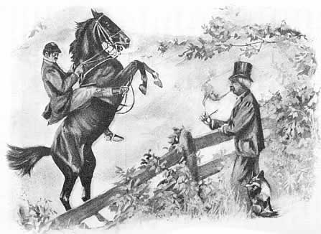
In order to determine the difference between an anaconda and an earl (if any) I caused seven young calves to be turned into the anaconda's cage. The grateful reptile immediately crushed one of them and swallowed it, then lay back satisfied. It showed no further interest in the calves, and no disposition to harm them. I tried this experiment with other anacondas; always with the same result. The fact stood proven that the difference between an earl and an anaconda is that the earl is cruel and the anaconda isn't; and that the earl wantonly destroys what he has no use for, but the anaconda doesn't. This seemed to suggest that the anaconda was not descended from the earl. It also seemed to suggest that the earl was descended from the anaconda, and had lost a good deal in the transition.
I was aware that many men who have accumulated more millions of money than they can ever use have shown a rabid hunger for more, and have not scrupled to cheat the ignorant and the helpless out of their poor servings in order to partially appease that appetite.
I furnished a hundred different kinds of wild and tame animals the opportunity to accumulate vast stores of food, but none of them would do it. The squirrels and bees and certain birds made accumulations, but stopped when they had gathered a winter's supply, and could not be persuaded to add to it either honestly or by chicane. In order to bolster up a tottering reputation the ant pretended to store up supplies, but I was not deceived. I know the ant. These experiments convinced me that there is this difference between man and the higher animals: he is avaricious and miserly; they are not.
In the course of my experiments I convinced myself that among the animals man is the only one that harbors insults and injuries, broods over them, waits till a chance offers, then takes revenge. The passion of revenge is unknown to the higher animals.
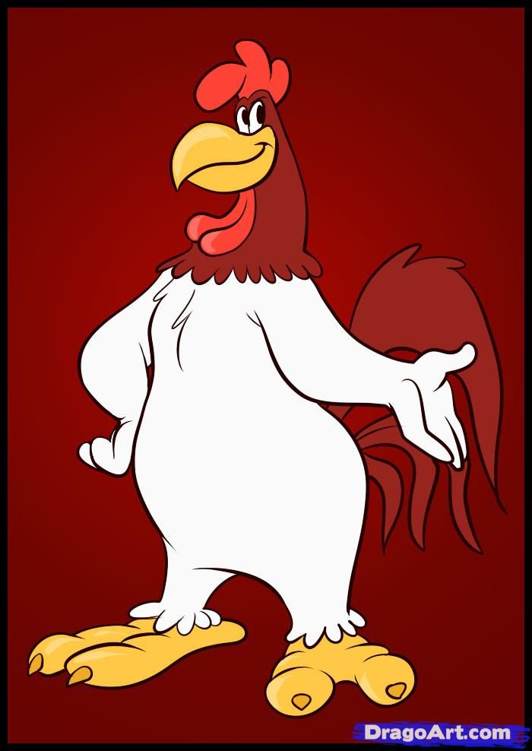
Roosters keep harems, but it is by consent of their concubines; therefore no wrong is done. Men keep harems but it is by brute force, privileged by atrocious laws which the other sex were allowed no hand in making. In this matter man occupies a far lower place than the rooster.
Cats are loose in their morals, but not consciously so. Man, in his descent from the cat, has brought the cats looseness with him but has left the unconsciousness behind (the saving grace which excuses the cat). The cat is innocent, man is not.
Indecency, vulgarity, obscenity (these are strictly confined to man); he invented them. Among the higher animals there is no trace of them.
They hide nothing; they are not ashamed. Man, with his soiled mind, covers himself. He will not even enter a drawing room with his breast and back naked, so alive are he and his mates to indecent suggestion. Man is The Animal that Laughs. But so does the monkey, as Mr. Darwin pointed out; and so does the Australian bird that is called the laughing jackass. No! Man is the Animal that Blushes. He is the only one that does it or has occasion to.
At the head of this article we see how "three monks were burnt to death" a few days ago, and a prior "put to death with atrocious cruelty." Do we inquire into the details? No; or we should find out that the prior was subjected to unprintable mutilations. Man (when he is a North American Indian) gouges out his prisoner's eyes; when he is King John, with a nephew to render untroublesome, he uses a red-hot iron; when he is a religious zealot dealing with heretics in the Middle Ages, he skins his captive alive and scatters salt on his back; in the first Richard's time he shuts up a multitude of Jew families in a tower and sets fire to it; in Columbus's time he captures a family of Spanish Jews and (but that is not printable; in our day in England a man is fined ten shillings for beating his mother nearly to death with a chair, and another man is fined forty shillings for having four pheasant eggs in his possession without being able to satisfactorily explain how he got them). Of all the animals, man is the only one that is cruel. He is the only one that inflicts pain for the pleasure of doing it.
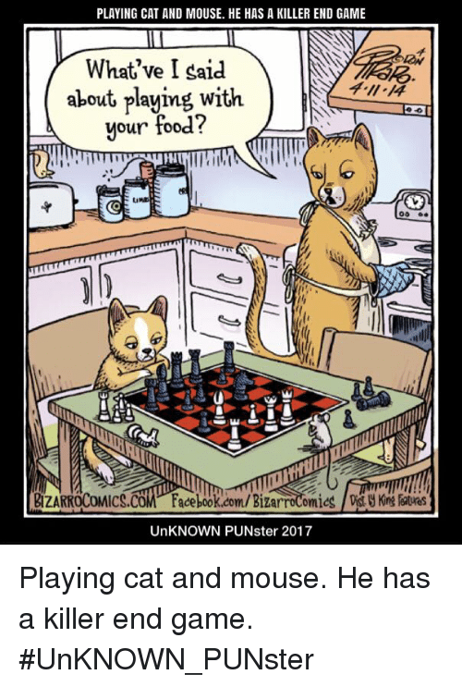
It is a trait that is not known to the higher animals. The cat plays with the frightened mouse; but she has this excuse, that she does not know that the mouse is suffering. The cat is moderate -- unhumanly moderate: she only scares the mouse, she does not hurt it; she doesn't dig out its eyes, or tear off its skin, or drive splinters under its nails -- man-fashion; when she is done playing with it she makes a sudden meal of it and puts it out of its trouble. Man is the Cruel Animal. He is alone in that distinction.
The higher animals engage in individual fights, but never in organized masses. Man is the only animal that deals in that atrocity of atrocities, War. He is the only one that gathers his brethren about him and goes forth in cold blood and with calm pulse to exterminate his kind. He is the only animal that for sordid wages will march out, as the Hessians did in our Revolution, and as the boyish Prince Napoleon did in the Zulu war, and help to slaughter strangers of his own species who have done him no harm and with whom he has no quarrel.
Man is the only animal that robs his helpless fellow of his country -- takes possession of it and drives him out of it or destroys him. Man has done this in all the ages. There is not an acre of ground on the globe that is in possession of its rightful owner, or that has not been taken away from owner after owner, cycle after cycle, by force and bloodshed.
Man is the only Slave. And he is the only animal who enslaves. He has always been a slave in one form or another, and has always held other slaves in bondage under him in one way or another. In our day he is always some man's slave for wages, and does that man's work; and this slave has other slaves under him for minor wages, and they do his work. The higher animals are the only ones who exclusively do their own work and provide their own living.
Man is the only Patriot. He sets himself apart in his own country, under his own flag, and sneers at the other nations, and keeps multitudinous uniformed assassins on hand at heavy expense to grab slices of other people's countries, and keep them from grabbing slices of his. And in the intervals between campaigns, he washes the blood off his hands and works for the universal brotherhood of man, with his mouth.
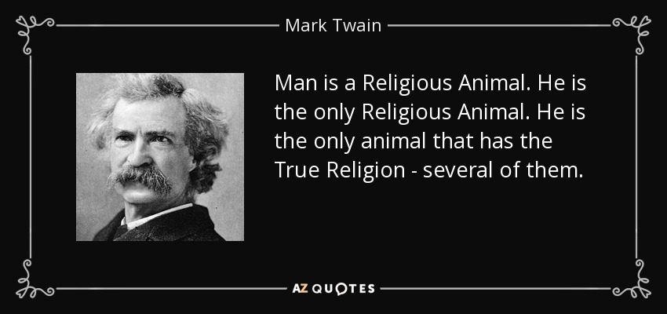
Man is the Religious Animal. He is the only Religious Animal. He is the only animal that has the True Religion -- several of them. He is the only animal that loves his neighbor as himself, and cuts his throat if his theology isn't straight. He has made a graveyard of the globe in trying his honest best to smooth his brother's path to happiness and heaven. He was at it in the time of the Caesars, he was at it in Mahomet's time, he was at it in the time of the Inquisition, he was at it in France a couple of centuries, he was at it in England in Mary's day, he has been at it ever since he first saw the light, he is at it today in Crete (as per the telegrams quoted above), he will be at it somewhere else tomorrow. The higher animals have no religion. And we are told that they are going to be left out, in the Hereafter. I wonder why? It seems questionable taste.
Man is the Reasoning Animal. Such is the claim. I think it is open to dispute. Indeed, my experiments have proven to me that he is the Unreasoning Animal. Note his history, as sketched above. It seems plain to me that whatever he is he is not a reasoning animal. His record is the fantastic record of a maniac. I consider that the strongest count against his intelligence is the fact that with that record back of him he blandly sets himself up as the head animal of the lot: whereas by his own standards he is the bottom one.
In truth, man is incurably foolish. Simple things which the other animals easily learn, he is incapable of learning. Among my experiments was this. In an hour I taught a cat and a dog to be friends. I put them in a cage. In another hour I taught them to be friends with a rabbit. In the course of two days I was able to add a fox, a goose, a squirrel and some doves. Finally a monkey. They lived together in peace; even affectionately.
Next, in another cage I confined an Irish Catholic from Tipperary, and as soon as he seemed tame I added a Scotch Presbyterian from Aberdeen. Next a Turk from Constantinople; a Greek Christian from Crete; an Armenian; a Methodist from the wilds of Arkansas; a Buddhist from China; a Brahman from Benares. Finally, a Salvation Army Colonel from Wapping. Then I stayed away two whole days. When I came back to note results, the cage of Higher Animals was all right, but in the other there was but a chaos of gory odds and ends of turbans and fezzes and plaids and bones -- not a specimen left alive. These Reasoning Animals had disagreed on a theological detail and carried the matter to a Higher Court.
One is obliged to concede that in true loftiness of character, Man cannot claim to approach even the meanest of the Higher Animals. It is plain that he is constitutionally incapable of approaching that altitude; that he is constitutionally afflicted with a Defect which must make such approach forever impossible, for it is manifest that this defect is permanent in him, indestructible, ineradicable.
I find this Defect to be the Moral Sense. He is the only animal that has it. It is the secret of his degradation. It is the quality which enables him to do wrong. It has no other office. It is incapable of performing any other function. It could never hate been intended to perform any other. Without it, man could do no wrong. He would rise at once to the level of the Higher Animals.

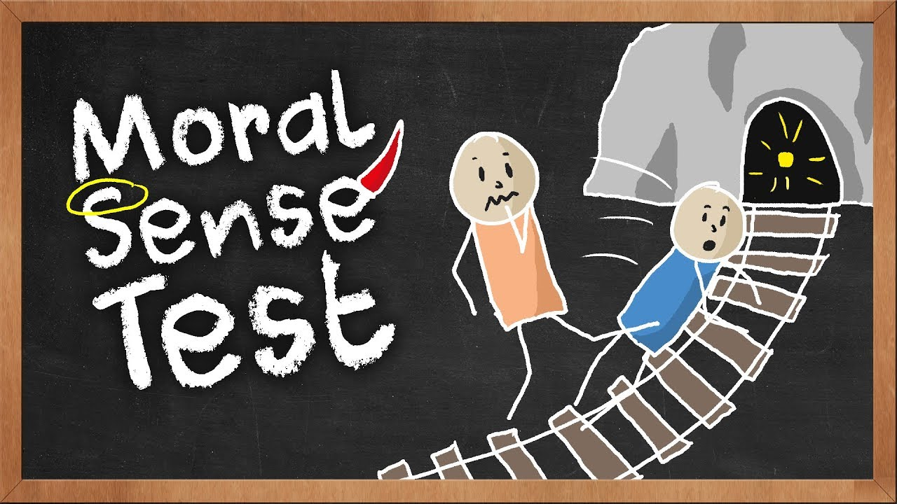
Since the Moral Sense has but the one office, the one capacity -- to enable man to do wrong -- it is plainly without value to him. It is as valueless to him as is disease. In fact, it manifestly is a disease. Rabies is bad, but it is not so bad as this disease. Rabies enables a man to do a thing, which he could not do when in a healthy state: kill his neighbor with a poisonous bite. No one is the better man for having rabies: The Moral Sense enables a man to do wrong. It enables him to do wrong in a thousand ways. Rabies is an innocent disease, compared to the Moral Sense. No one, then, can be the better man for having the Moral Sense. What now, do we find the Primal Curse to have been? Plainly what it was in the beginning: the infliction upon man of the Moral Sense; the ability to distinguish good from evil; and with it, necessarily, the ability to do evil; for there can be no evil act without the presence of consciousness of it in the doer of it.
And so I find that we have descended and degenerated, from some far ancestor (some microscopic atom wandering at its pleasure between the mighty horizons of a drop of water perchance) insect by insect, animal by animal, reptile by reptile, down the long highway of smirchless innocence, till we have reached the bottom stage of development -- nameable as the Human Being. Below us -- nothing. Nothing but the Frenchman.

